Chapter 5, Solution 93.
+
v_{o}
−
R₃
R₂
R₁
v_{a}
−
+
i_{L}
i_{o}
R_{L}
R₄
v_{b}
+
v_{L}
−
+
v_{i}
−

At node a, (v_{i} – v_{a})/R₁ = (v_{a} – v_{o})/R₃

v_{i} – v_{a} = (R₁/R₃)(v_{a} – v_{o})

v_{i} + (R₁/R₃)v_{o} = (1 + R₁/R₃)v_{a} (1)

But v_{a} = v_{b} = v_{L}. Hence, (1) becomes

v_{i} = (1 + R₁/R₃)v_{L} – (R₁/R₃)v_{o} (2)

i_{o} = v_{o}/(R₄ + R₂||R_{L}), i_{L} = (R₂/(R₂ + R_{L}))i_{o} = (R₂/(R₂ + R_{L}))(v_{o}/( R₄ + R₂||R_{L}))

Or, v_{o} = i_{L}[(R₂ + R_{L})( R₄ + R₂||R_{L})/R₂ (3)

But, v_{L} = i_{L}R_{L} (4)

Substituting (3) and (4) into (2),

v_{i} = (1 + R₁/R₃) i_{L}R_{L} – R₁[(R₂ + R_{L})/(R₂R₃)]( R₄ + R₂||R_{L})i_{L}

= [((R₃ + R₁)/R₃)R_{L} – R₁((R₂ + R_{L})/(R₂R₃)(R₄ + (R₂R_{L}/(R₂ + R_{L}))]i_{L}

= (1/A)i_{L}

Thus,

A = 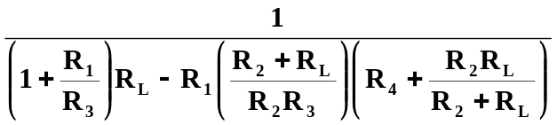

Please note that A has the units of mhos. An easy check is to let every resistor equal 1-ohm and v_{i} equal to one amp. Going through the circuit produces i_{L} = 1A. Plugging into the above equation produces the same answer so the answer does check.

